Childhood Obesity: The epidemic is spreading!

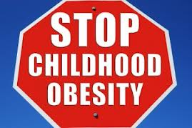

One of the biggest challenges of the 21st century is to keep one half of the world’s population from starving and the other half from overeating! What was exclusively a western malaise till the last decade has well and truly become a problem for the developing world. Added to this is the misconception in many communities that being ‘chubby’ reflects “good health”! Being overweight or obese is not an adult problem alone and increasingly, I am seeing more and more children in clinic with a serious weight problem.
Being obese or overweight has serious implications for children’s health. Overweight children are also more likely to end up as overweight or obese adults. If the problem of being overweight is managed properly in childhood, some of these health problems may be reversed, or even prevented. This increases the likelihood of the child growing up to be an adult with a healthy weight.

How common is obesity in children?
No one knows the exact figure for India. Childhood obesity is more problematic in urban compared to rural areas. Figures for the UK suggest that there are about three million children who are overweight or obese. This means about one in every three British children has a serious weight problem.

How do you know if your child is obese?
Doctors can check to see whether the child is overweight or obese by calculating their Body Mass Index (BMI). BMI is a measure of the child's weight in relation to their height. Checking the weight alone is inaccurate as a taller child is bound to be heavier. However, it is important to know that a child's BMI is not interpreted in the same way as an adult's BMI. Instead, the BMI of the child is compared with centile charts which take into account their age and sex. These centile charts can show how the child's BMI compares with the normal range of BMIs for children of the same age.
What are the health implications if the child remains obese?
One of the most worrying aspects is that such health problems have traditionally been seen only in adults but now are seen in younger children.
There is an increased risk of the following conditions:
- Type 2 Diabetes mellitus
- Fatty liver disease
- Joint problems due to the increased weight being carried
- Going through puberty early (called precocious puberty). This means girls showing signs of puberty before 8 years of age and boys before 9 years of age.
- Menstrual irregularities in teenaged girls
- High blood pressure
- Breathing problems most evident when they feel out of breath easily. In addition, snoring while asleep may be suggestive of a condition called obstructive sleep apnoea.
- More than 50% of children who are obese will grow up to be obese adults and coronary artery disease could well be a problem in their twenties and thirties.
- Psychological problems: Being overweight or obese as a child or teenager can lead to low self-esteem and a lack of confidence. A child may be bullied at school because of their weight.

What causes obesity in children?
We need to consider five possible contributing factors for obesity:

How much a child eats and drinks
Many children are overweight or obese simply because they eat and drink more than their body needs. Having too many foods or drinks that are too sugary or fatty is a common problem.

A lack of physical activity or exercise
A child may be eating the right type and the right amount of food but, if they are not doing enough physical activity, they may put on weight. Spending large amounts of time being sedentary or inactive in front of the television or playing video games contributes to weight gain in a major way. Having parents who are inactive can also increase a child's risk of being overweight or obese.

Parents and inherited genes
Being obese does run in families.50% of children who have one parent who is obese will become obese themselves. More worryingly, 80% of children who have two parents who are obese will also become obese themselves.
This is due to many reasons. For one, children may have learnt unhealthy eating habits from their parents. But, it may also be due to genetic factors also which makes some people prone to overeating. It is not fully understood how this genetic factor works. In some people, the control of appetite and the feeling of fullness (satiety) may be faulty, or not as good as it is in others.
However, it is not inevitable that you will become obese even if you have inherited these genetic factors. You may find it more difficult to stop yourself from gaining weight or to lose weight.

The importance of a good night’s sleep
There is a trend of children going to bed later than we did when we were children but in addition, too little physical exercise can lead to poor sleep.
Two hormones called Leptin and Ghrelin have an important relationship with sleep. Leptin is released by fat cells to tell your brain that your fat stores are sufficient. Ghrelin is released by your stomach as a signal of hunger. In someone who does not have enough sleep, Leptin levels are low and Ghrelin levels are high. These changes in hormone levels may encourage a child to eat more.

Medical causes for obesity
Sometimes, there is an underlying medical cause for a child being overweight or obese. This may be picked up on clinical examination or blood tests. There are some rare genetic diseases that can cause obesity in children. Conditions such as hypothyroidism or other hormone problems may also be a cause.

What treatment is available for childhood obesity?
Lifestyle changes involving a healthy diet and increased physical exercise are the cornerstones of achieving a healthy weight. Small, gradual changes may be best. The child will then be more likely to stick to these changes in the long-term.
Changes that involve the whole family are best. Other family members who are overweight may also benefit at the same time. It is vital to remember that parents act as an important role model for the child and can help them to stay healthy.
It is important to be encouraging them as they adapt to a new diet and exercise regime and not to be too critical if there is a setback, especially in the early stages.

Twelve top tips to aid weight loss
- Turn off the TV while eating Have regular meal times at the table as a whole family. Do not sit in front of the TV when eating. You may remember having finished a packet of biscuits or potato chips in no time while watching TV. Your brain is concentrating on something else and may be ignoring the signals from your full stomach.
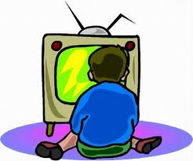
- Beware ‘Snack attack’ Avoid offering unhealthy snacks in between meals as much as possible. Snacking between meals will interfere with the appetite for main meals and this often ends up as a vicious circle with your child being hungry 2 hours after a main meal. If snacks are eaten, they should be healthy snacks like fruit instead of sweets, chocolates, potato chips, nuts, biscuits, and cakes. You can offer a chocolate or sweet after a main meal on a few occasions a month rather than banning them completely which is unlikely to work.
- Fruit fun Encourage your child to have a fruit before every meal: a banana or apple or orange. This will reduce the amount they eat during their meal and the fibre will give them a sensation of fullness. The international recommendation is that children need to have 5 portions of fruit and vegetable a day.
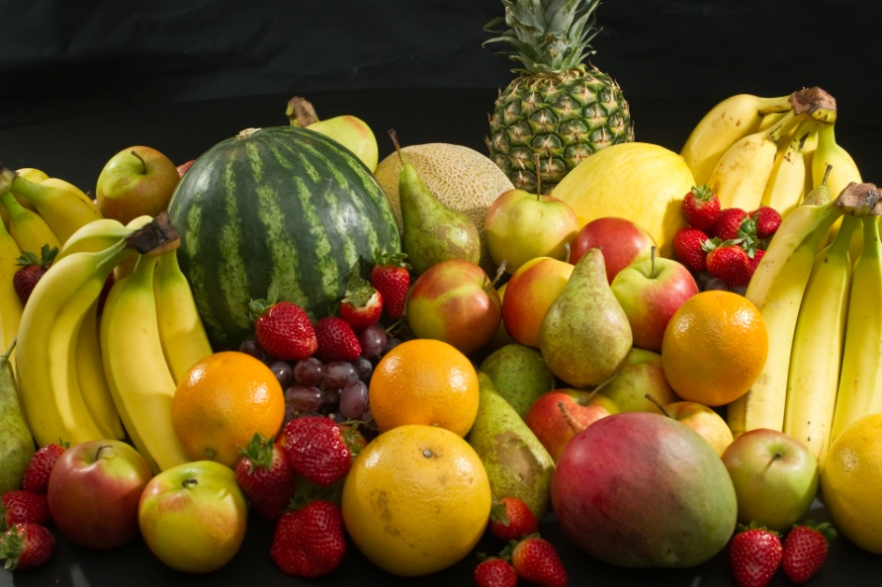
- (Plate) Size matters Try using a smaller plate and encourage your child to watch the portion sizes of the food that they are eating. An eight year old child should not be eating the same amount as an adult!
- Starch march Make up the bulk of most of your child's meals with starch-based foods (such as chapattis, and rice). Wholegrain starch-based foods should be eaten when possible.
- Fibre fills you up Make sure that your child eats plenty of foods high in fibre. Foods rich in fibre include wholegrain bread, brown rice, oats, peas, lentils, grain, beans, fruit and vegetables. Amongst other things, foods high in fibre will help to fill your child up.
- H₂O Peelo Encourage your child to drink plenty of water. If they loves their soft drinks, try low-calorie drinks rather than bottled or packaged fruit juices and soft drinks which are loaded with sugar. If your child is very keen on bottled soft drinks, one option is to go for the diet drinks (Diet Coke and Diet Pepsi) which have no sugar.
- Fat storehouses Fried foods and bakery items like cakes, samosas and puffs have plenty of hidden fat calories in them. Many supermarket brands of potato chips now offer ‘baked’ potato chips which have much less fat.
- ‘There is no food like home food’ Restaurant food and fast foods like pizza and burgers have plenty of fat and calories. Use your judgment to take them out on special occasions only and make sure they don’t overeat. Try to avoid ‘buffet deals’ where you overeat to get your ‘money’s worth’!
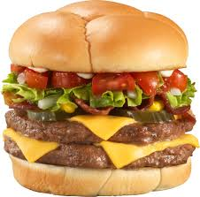
- Sweat it out It is recommended that all children should do at least 60 minutes of moderate physical activity every day. These 60 minutes do not have to be done all at once and can be broken up into two 30 minute blocks. Exercising for 10-20 minutes causes you to burn calories from carbohydrates and proteins and only after exercising for 20-25 minutes, do you start to burn fat. A useful starting exercise would be brisk walking which should make them sweat. If you have a motorbike or car, mark out a distance of 1 km from your house. Encourage your child to walk to that point and back at least 5-6 times a week. You should not invest in a treadmill for walking exercise unless you are very motivated and can afford it. I know of families who use treadmills to hang clothes as they are not being used for any other purpose!
- Ban the couch potato You should encourage your child to become generally less sedentary. The total time recommended internationally watching television, using a computer, or playing video games, is less than two hours each day.
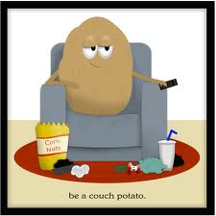
- Fitness funtime Encourage active play for your child including games that involve moving around a lot, such as cycling, dancing, running, playing cricket or football.

Drug treatments
As a rule, drug treatment is not usually used to help children and teenagers lose weight. However, in the most extreme cases, the drug Orlistat may be prescribed to help children aged 12 or over who are severely obese with severe health problems because of their obesity. Orlistat works by interfering with the way that fat is digested and absorbed into the body.

Weight loss surgery
Surgery to help weight loss, also called bariatric surgery, is not usually carried out in children. Only in very exceptional circumstances where the child’s health is at serious risk with weight gain continuing relentlessly would this option be considered. It would solely be the last resort for teenagers who have already gone through puberty and who are severely obese with severe health problems caused by their obesity.
In summary, the best way to treat a child who is overweight or obese is to look at changes that can be made to their lifestyle. Such changes include eating more healthily and doing plenty of physical exercise. Changes that involve the whole family are best and are most likely to be successful. It is vital that parents support their children and are not too critical. Encouragement to persevere with the new diet and fitness regime will yield long term rewards for the child and their parent’s health too!
Dr Cheri Mathews John MBBS, DCH, MRCPCH (UK), FRCPCH (UK), CCT (Paediatrics)
Consultant Paediatrician

Angel’s Speciality Clinic, AL-190, 1st street, 12th Main Road, Shanthi Colony, Anna Nagar, Chennai 600 040

